PRACTICAL QUESTIONS FOR DATA VISUALISATION AND ANALYTICS (CIA1C11)
Practical 4 – Exploratory Data Analysis III (Categorical Data)

Introduction: Given a set of raw data, what is the process that one might go through to make sense of the data? Exploratory Data Analysis is about getting to know the data, discovering the problem areas and assessing what needs to be done to improve the data quality. Generally, these are the things that a data analyst will have to go through:
- Data Profiling – to get an overview structure of the data and assess the data quality
- Data Discover – to use statistics charts to get a sense of the distribution / correlation

Practical 2-4 will introduce students to the application of such Exploratory Data Analysis.

Objective: Unlike Practical 3 where the focus was on Numeric (Quantitative) data, the aim of Practical 4 is to focus on the EDA techniques for non-numeric (categorical / nominal) data.

Question 1 : To get a sense of the non-numeric data via profiling (Statistics, CrossTab, GroupBy node)
Question 2 : To explore non-numeric data using visualizations (pie, scatter plot, sunburst chart)

Dataset: For our task this week, we will make use of a dataset containing survey returns of IT Professionals from various countries on their views of their employer’s attitudes towards and support for the mental health of employees. For more details, you can visit this link (https://www.kaggle.com/osmi/mental-health-in-tech-survey/data)

Unlike the previous datasets that we have encountered, the data in this dataset is mostly non-numeric. Let’s see how we can handle and explore non-numeric data.

Ready? Let’s get started!

Question 1 (Statistics Node, Cross Tab, Group By)
The purpose of this question is to get a sense of the non-numeric data via profiling/audit.
The questions to consider are:
- Can you find anything interesting in one-dimensional frequency tables? (statistics node)
- Can you find anything interesting in two-dimensional tables? (crosstab node)
- Can you find anything interesting in multi-dimensional summary/pivot tables? (GroupBy node)

In the process of exploring the data, we may be able to discover things such as:

- What is the breakdown of survey respondents by country?
- Among respondents from US, which states have the most respondents?
- What is the breakdown of survey respondents by both country and gender?
- What is the average age of male and female respondents for each country?

- Create a new KNIME Workflow P04_Q1 in the DAVA Workflow Group.
Using the File Reader node, read the dataset mental_health_small.csv into the workflow.

Execute the File Reader node, then right-click and select File Table.
Verify that you have 982 rows and 25 columns.

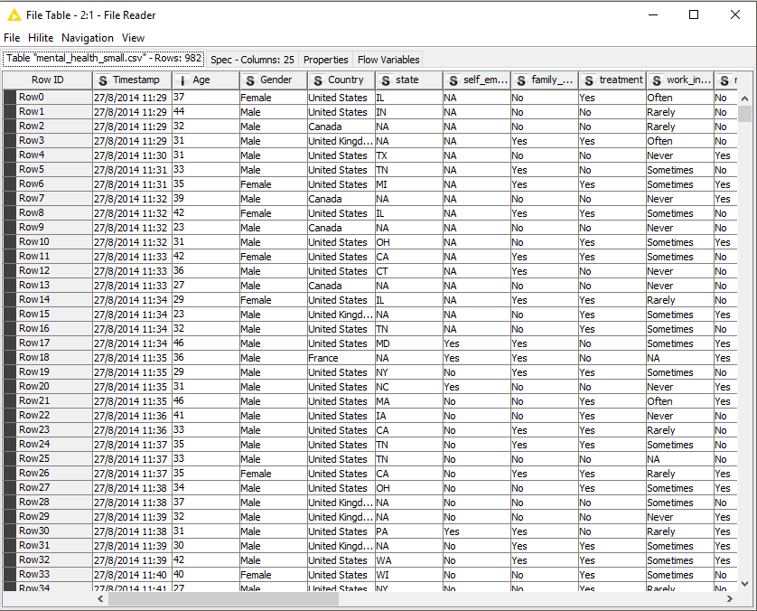

One of the more convenient way that we can use to get a feel of what we have imported is to go the Spec – Column tab. We can see that for categorical column Gender, there are 2 possible values: Female and Male, similarly, for Country, there are 4 possible values: United States, Canada, United Kingdom and France.

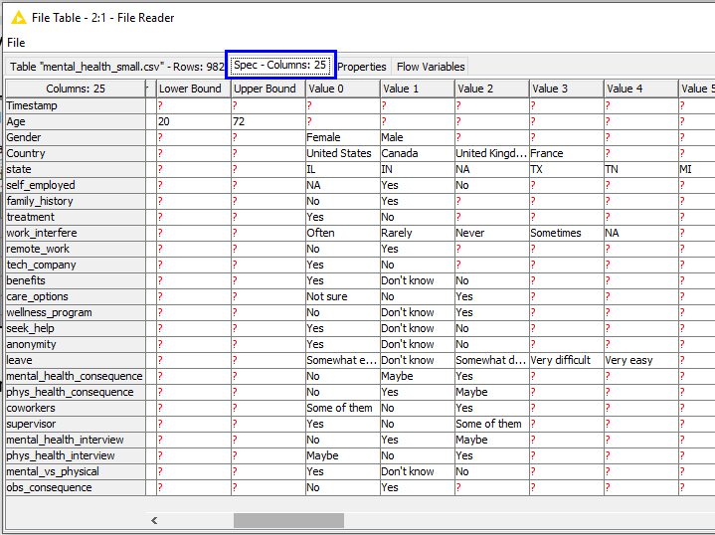

 | Question:  - What is the breakdown of survey respondents by country?
Answer:

At the point, we still do not know the breakdown yet, but we know that respondents are from United States, Canada, United Kingdom and France.

Close the File Table view.

- Connect a Statistics node from the File Reader node, verify that all fields are included. Select Execute and Open View for the Statistics node.

Navigate to the Nominal tab. We can see whether there are any missing values for each of the nominal column. The accompany histogram also shows the distribution of values for the nominal field. Hover over the bars to see more info for each category.

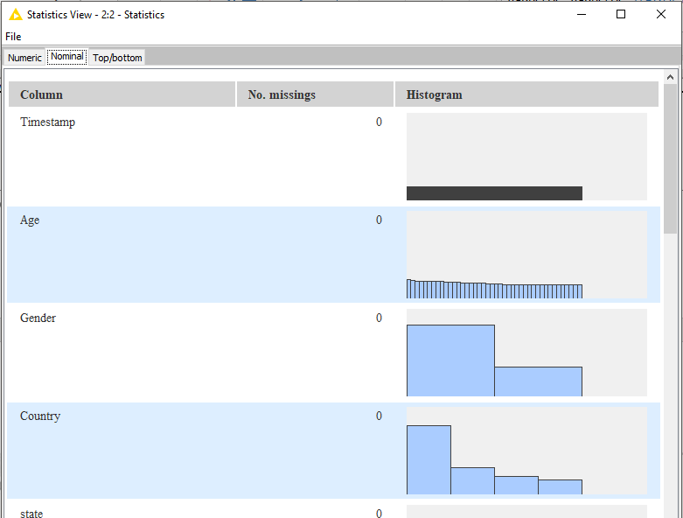

Navigate to the Top/bottom tab, we can also see the raw count of each value. For example, we can see that the self_employed field contained 876 No, 89 Yes and 17 NA.
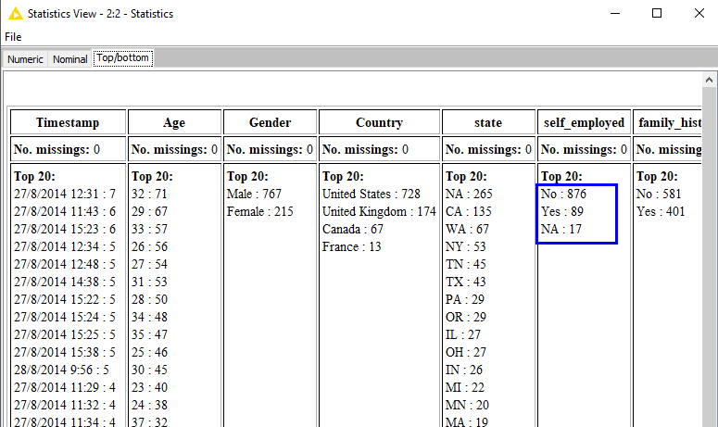

 | Question (same as above) :  - What is the breakdown of survey respondents by country?
Answer:

Close the Statistics View.

- Right-click on the Statistics node and select Occurrences Table.

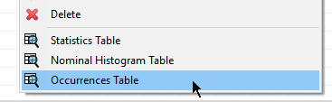

The Occurrences Table shows the frequency of each value for each field, while it may not make sense to look at frequencies for date / time and numeric fields like Age, it is useful information when it comes to nominal fields. In this example, we can see the respective frequencies for each country. The Occurrences Table is particularly useful for the state field, since not all states are captured in the Top/bottom tab.

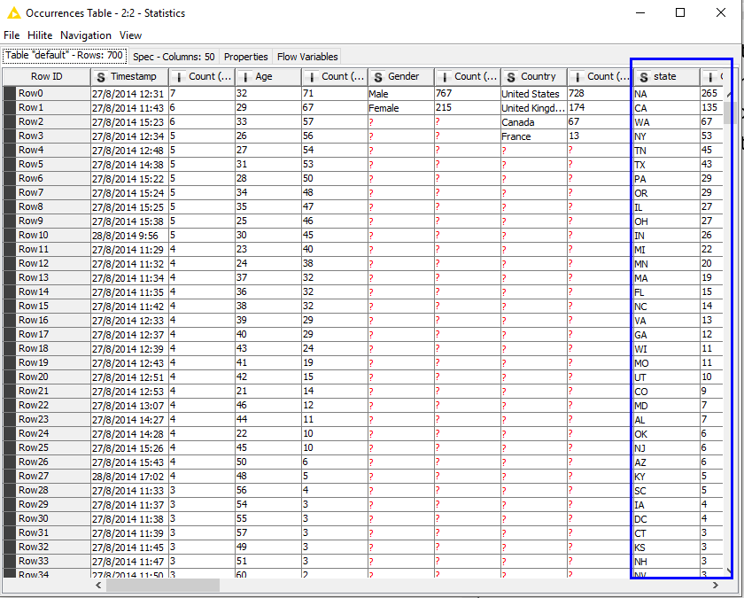

 | Question:  - Among respondents from US, which states have the most respondents? (Note : NA means Not Applicable)
Answer:

- Next, we will add a Crosstab node to the File Reader node. Configure the Crosstab node as follows:
- Row variable: Gender
- Column variable: Country
- Weight column: none

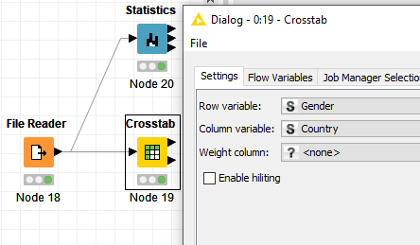

Execute and Open Views. Uncheck all details except for Frequency.

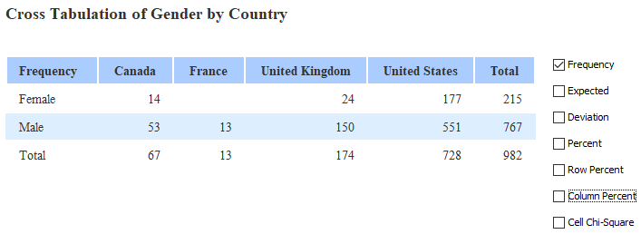

 | Question:  - What is the breakdown of survey respondents by both country and gender?  What happens if you show by Percent?  What is the difference between Percent, Row Percent, Column Percent?
Answer:

- Next, change the configuration of the Crosstab node as follows:
- Row variable: Gender
- Column variable: Country
- Weight column: Ages

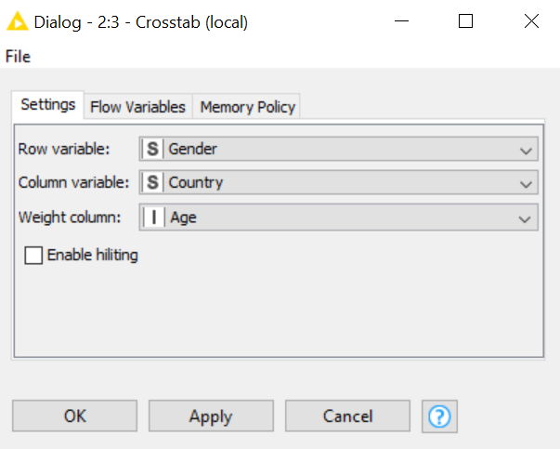

Execute and Open Views. Uncheck all details except for Frequency.

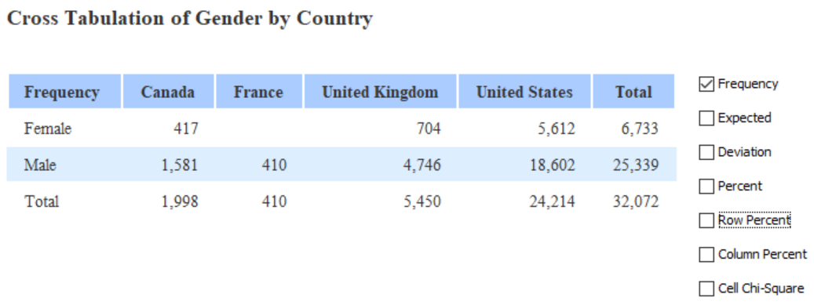

 | Question:  - What do the number in the cross-tabulation table indicate?
Answer:

Note
As we are unable to change sum to other aggregation methods (e.g. average), we need to find a more flexible way to enhance our exploration. To do that, we will next look at the GroupBy node.

- Add a GroupBy node to the File Reader node. Your Workflow should resemble what is shown below.
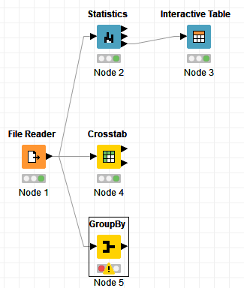
Configure the GroupBy node by selecting Gender and Country as the grouping fields.
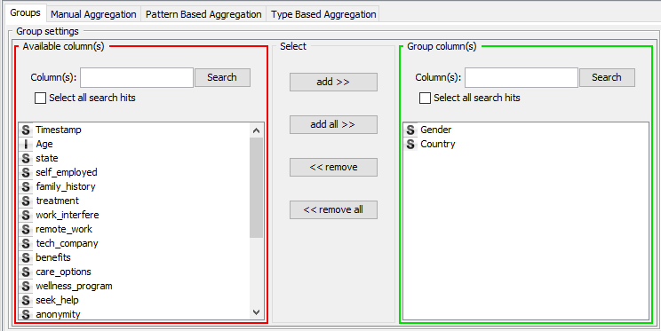
The GroupBy node aggregates records based on the selected field(s). The most common aggregation method is the count, other aggregations methods includes mean, sum, max, min etc. We will see more of this later.

In this instance, we want to find the means age for each sub-group of survey respondents.

- Navigate to the Manual Aggregation tab. We will select Age as the field to aggregate. Select the aggregation method as Mean. This means, we will compute the mean Age of respondents, grouped by the 2 fields we have selected: Country and Gender.

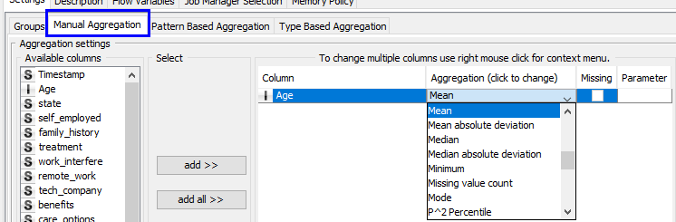
- Click Ok to confirm and close the configuration window.

Execute the GroupBy node. Right-click on the GroupBy node and select Group table to view the output.

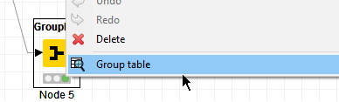

The output of the GroupBy node is shown below.

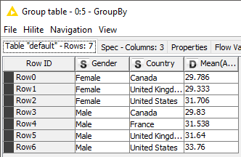

 | Question:  - What is the average age of male and female respondents for each country?
Answer:

Question 2 (Pie Chart, Color Manager, Scatterplot, Sunburst chart)
The purpose of this question is to explore non-numeric data using visualization.
The questions to consider are:
- Can you find anything interesting in one-dimensional charts? (pie chart)
- Can you find anything interesting in 2/3-dimensional charts? (color manager, scatter plot)
- Can you find anything interesting in > 3-dimensional charts? (sunburst chart)

In the process of exploring the data, we may be able to discover things such as:

- What percent of survey respondents are female?
- Do you see anything unusual in the scatter plot?
- What if you want to analyze by three or more dimension?

- Color Manager
We will continue from the same Workflow in Question 1.
Connect a Color Manager node from the File Reader node.
Select Gender as the column to assign colours to and assigned red to Female and blue to Male.
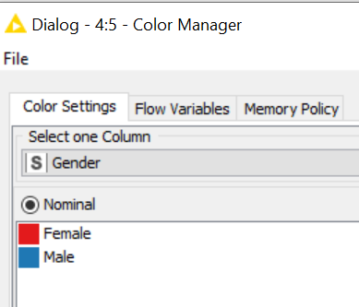

- Interactive Pie Chat
Connect Interactive Pie Chart node downstream from the Color Manager node.
Your Workflow should resemble the screenshot below.
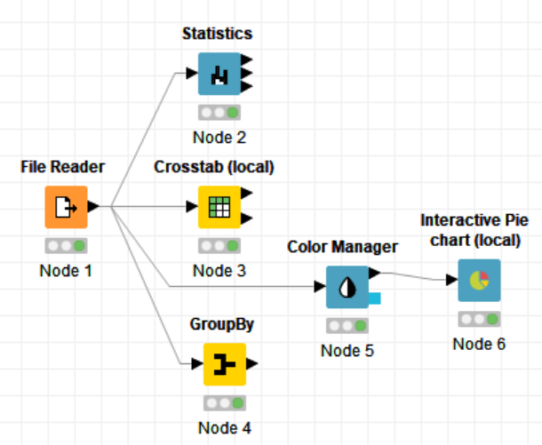

Incidentally, you can click on the link between node, a handle will show at the middle of the link that will allow you to create bends in the link so that your workflow is more readable.
- Configure the Interactive Pie Chart with the following settings:
- Pie Column: Gender
- Aggregate Column: none

Select Execute and Open View.
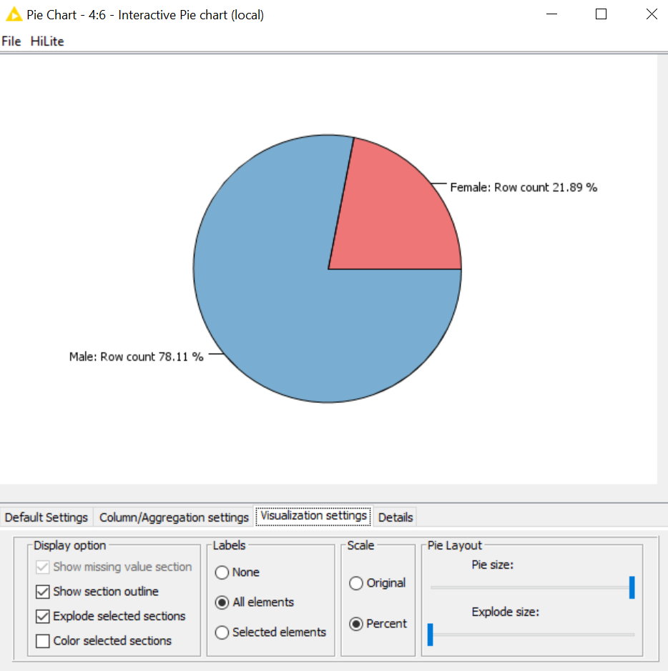

You can go to the Visualization settings tab of the output view to toggle the label of the Pie chart between percentages and raw count.

You can also click on any slice in the Pie chart to explode the selected slice, useful when the Pie chart has several small slices. To resume to original pie, click any white area outside the pie.

 | Question:  - What percent of survey respondents are female?
Answer:

What happens if you want to analyze for two dimensions?

- Scatter Plot
Connect a Scatter Plot under Local(Swing) found in the Views group downstream from the Color Manager node.

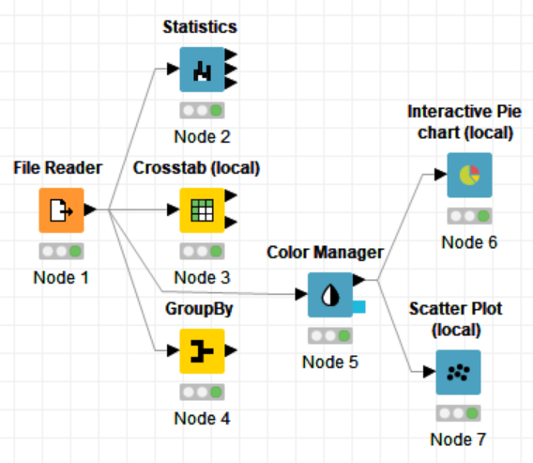
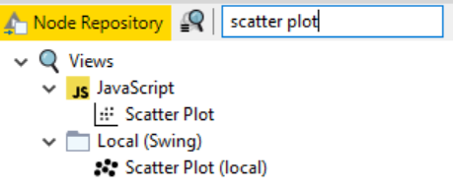

No configuration is required for now. Select Execute and Open Views

- Navigate to the Column Selection tab, change the X-Column to Leave and Y-Column to Country.
The column Leave indicates “How easy is it to take leave for a mental health condition?”
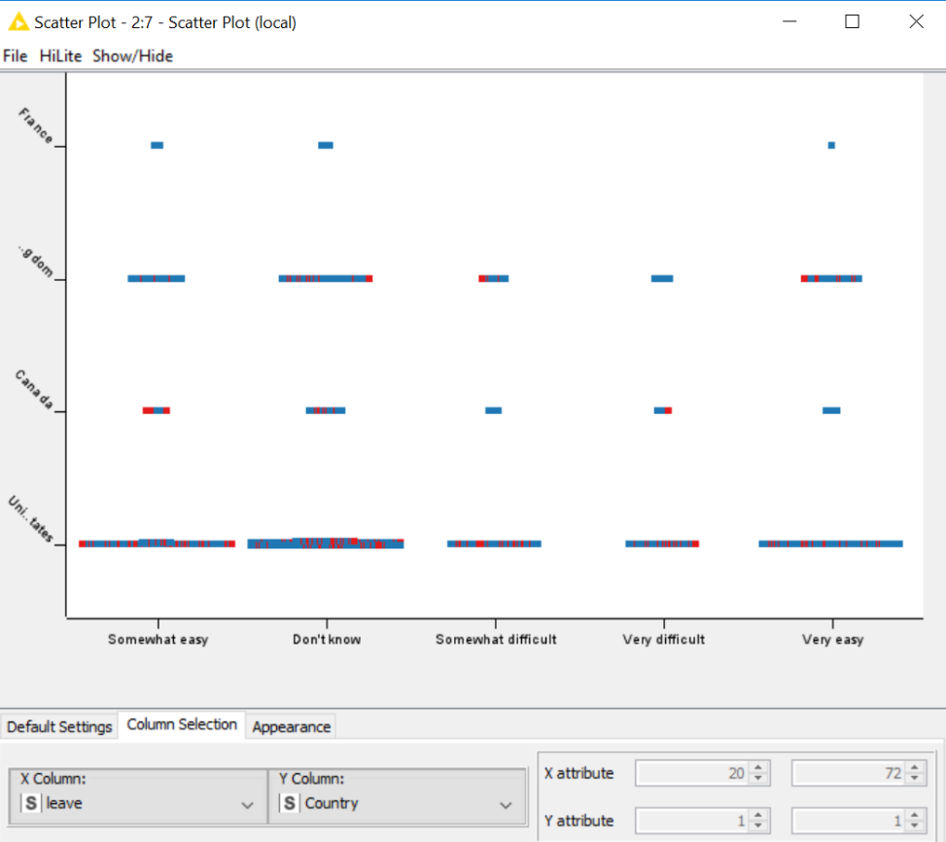

Such plots allow us to visualized distribution of data points broken down by one or two categorical fields. Used in conjunction with the Color Manager node, we can add a third dimension to the scatterplot.
 | Question:  g) Do you see anything unusual in the scatter plot?
Answer:

What happens of you want to analyze more than three or more dimensions?

- Sunburst Chart
Add a Javascript Sunburst Chart node downstream from the File Reader node. Configure the Sunburst chart node such that it is using the following fields:
- Gender
- Country
- Leave (How easy is it to take leave for a mental health condition?)
- Mental_health_consequence (Do you think that discussing a mental health issue with your employer would have negative consequence?)
- Obs_consequence (used as a dummy variable only)
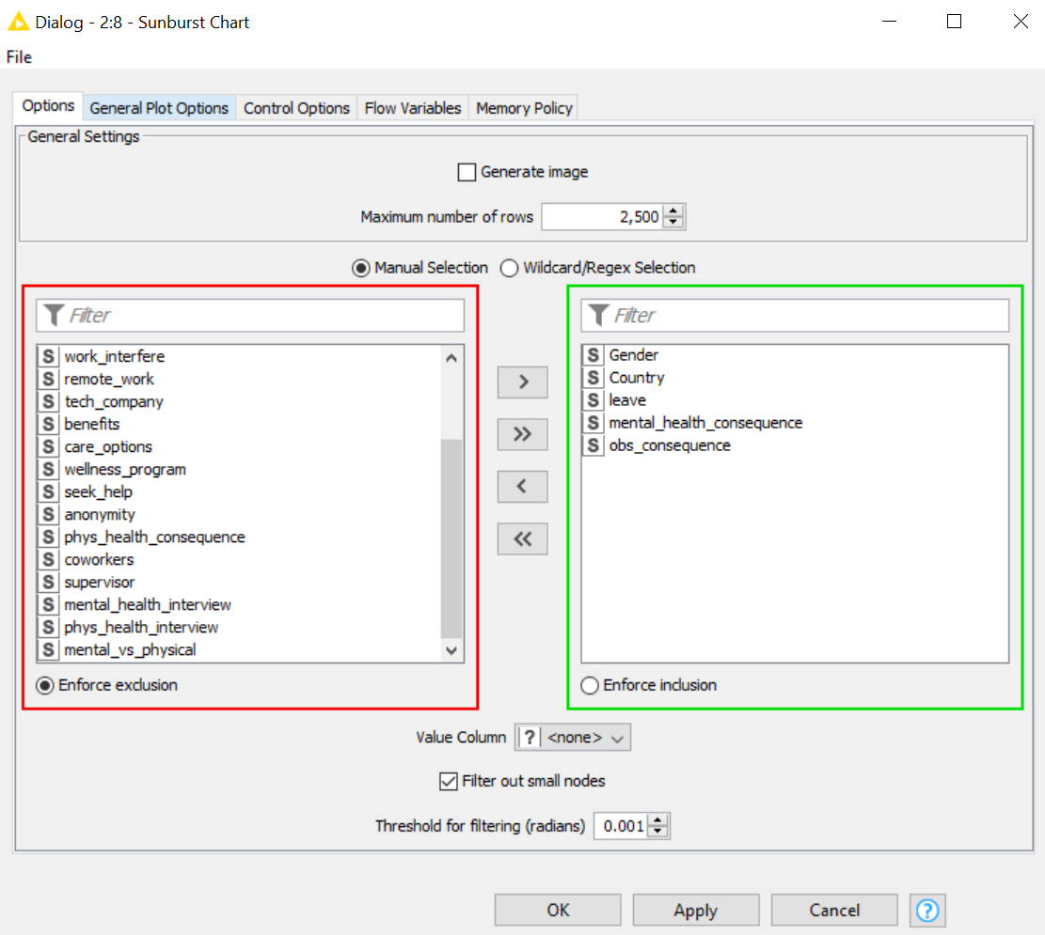

Select Execute and Open Views

The Sunburst chart allows you to explore the various categorical fields in a hierarchal view, as you move your mouse over each tier of the chart, the percentage in the middle of the chart will be updated to inform you what proportion of the dataset you are looking at.
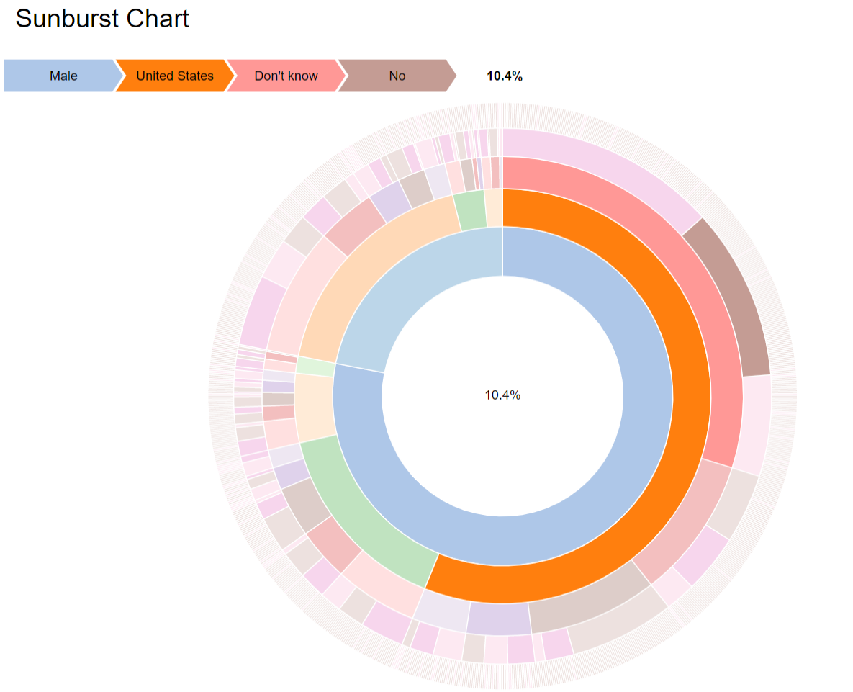

 | Question:  - What percentage of survey respondents are :  - female from the United States 18.0%  - don’t know how easy it is to take leave for mental health conditions  - think that “Yes, discussing a mental health issue with your employer would have negative consequence”?
Answer:
2.44%

 | Question:  - What happens if you remove Obs_consequence from the configuration of Sunburst node?
Answer:

- Save your workflow.

 | Reflection:  What is the appropriate node to use in the following situations?
Answer:

Analyze Using Tables Analyze Using Charts
One dimension |  |  | One dimension
Two dimensions |  |  | Two dimensions
Three or more |  |  | Three or more

– End of Practical 4 –

 | Summary:
In this practical, we explored techniques that we can use to explore non-numeric data. Since data is non-numeric, we cannot make use of summary statistics. When dealing with non-numeric data, we will base our exploration on the count of datapoints across different dimensions. This information can be presented using various visual charts such as bar chart, pie chart, scatter diagrams and sunburst diagrams.

In this practical we made use of the following nodes in KNIME.
Node |  | Purpose | Remarks
Statistics |  | Produce descriptive statistics for imported fields. | Computation of median is disabled by default
Crosstab |  | To produce a table-liked cross tabulation of two selected fields (one as the row, one as the column). | Weight column will modify the frequency of each record by the selected field, so one record is no longer counted as one occurrence, instead, it will be multiplied by the weight.
GroupBy |  | Groups the rows of a table by the unique values in the selected group columns.
Pie chart (interactive) |  | Produces pie chart for selected field | Can choose to display raw count or percentage
Scatter Plot |  | Shows one characteristic in relation to another. Strictly speaking, this is called a strip plot when used for categorical data | Can add colour to the points in the scatter plot and you get a to see 3 pieces of information in a single dot.
Sunburst Chart (java script) |  | This chart displays data in a hierarchical, radial layout.

